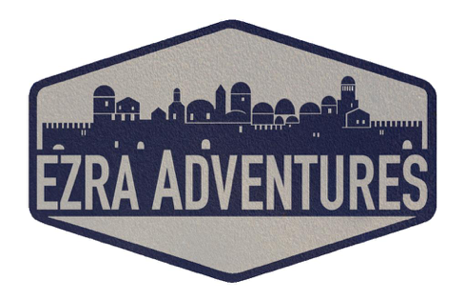

PACKING LIST

Besides your general clothing, toiletries, medications, you should bring with you:

- Spending & food cash (for meals not included in package)
- Photocopy of your passport
- Sweater/light coat
- Modest clothing for Shabbat and religious sites (see notes below)
- Comfortable walking shoes
- Bathing suit (Dead Sea)
- Sun hat
- Sunscreen
- Sunglasses
- Refillable water bottle (best insulated) - http://amzn.to/2bUJjEQ
- Camera
- Power adapters - http://amzn.to/2cClm2r or http://amzn.to/2c9fLzj;
(converters if needed - http://amzn.to/2bUISKW)

If needed:
- Dual voltage hairdryer - http://amzn.to/2bUIiNe (you will need just a power adapter for it, not converter)
- Noise cancelling headphones for the flight - http://amzn.to/2eDN6rs

MODESTY AT RELIGIOUS SITES
Israel is a casual country when it comes to dress. However, when visiting religious sites, “modest” clothing is appropriate. For those sites women should cover their shoulders and knees. We suggest bringing a scarf or cardigan to throw over your shoulders, plus a skirt that can be easily pulled over shorts for a more “modest” look. Pants or capris are also acceptable. Men should have their shoulders and knees covered on the days where religious sites are on the itinerary.
You can consider convertible pants that transition from long pants to shorts:
Men – http://amzn.to/2ce6yZP, http://amzn.to/2c9k51j, http://amzn.to/2ce8m4U
Women - http://amzn.to/2bZ8Fmk

SHABBAT ATTIRE
We recommend bringing something a bit nicer for Shabbat. A good rule of thumb is to bring something “a step up” from what you wear on a daily basis.
Nice and modest outfit for women; and a polo or buttoned-down shirt, with khakis or nice jeans for men.

